Project Design Phase
Solution Architecture

Date | 05 October 2026
Team ID | SWTID-2026-9175
Project Name | Auto Ticket Classification using Flow Designer
Maximum Marks | 4 Marks

Solution Architecture:
Solution architecture is a complex process – with many sub-processes – that bridges the gap between business problems and technology solutions. Its goals are to:
- Find the best tech solution to solve existing business problems.
- Describe the structure, characteristics, behavior, and other aspects of the software to project stakeholders.
- Define features, development phases, and solution requirements.
- Provide specifications according to which the solution is defined, managed, and delivered.

Solution Architecture Diagram – Auto Ticket Classification using Flow Designer

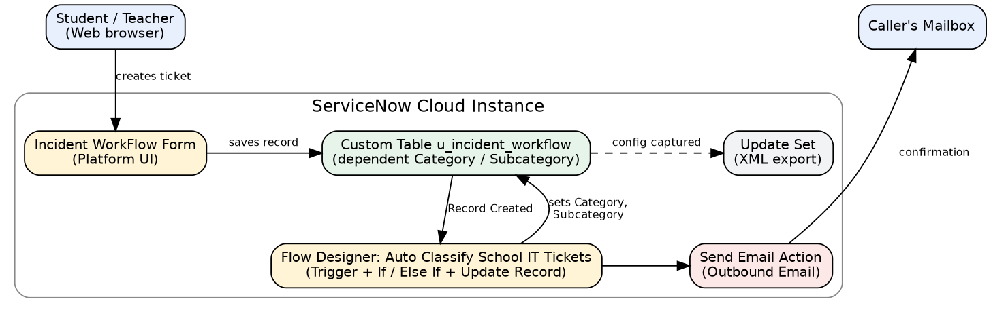
Figure 1: Architecture and data flow of the Auto Ticket Classification solution
Data flow:
1. A student or teacher opens the Incident WorkFlow form and enters Caller and Short Description.
2. The ticket is saved in the custom table u_incident_workflow with an auto-generated number.
3. The Flow Designer flow Auto Classify School IT Tickets triggers on Record Created when Category is empty.
4. If / Else If conditions check the Short Description keywords and the Update Record action sets Category and Subcategory.
5. The Send Email action sends a confirmation email to the caller's email address.
6. The project configuration is captured in an update set that is marked Complete and exported as XML.

